Create Account with Active value is true it automatically updated false once record created.

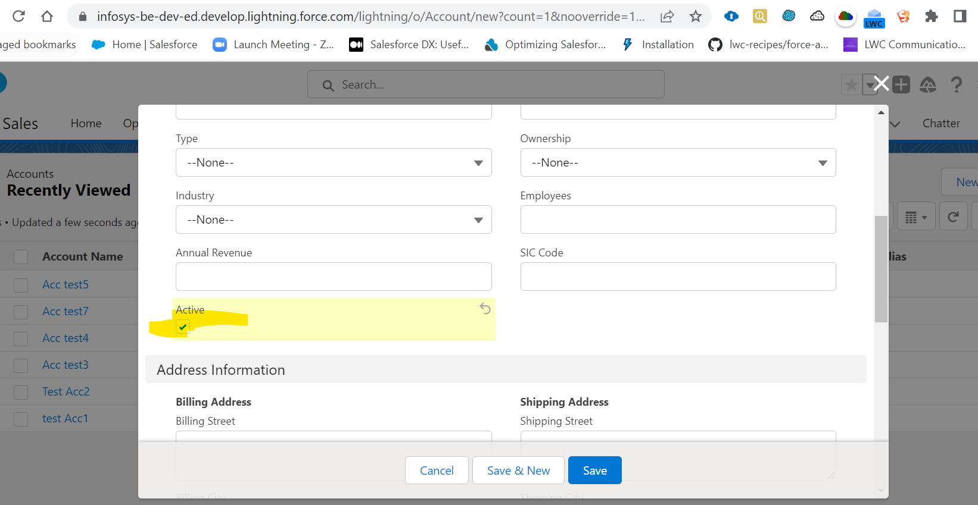

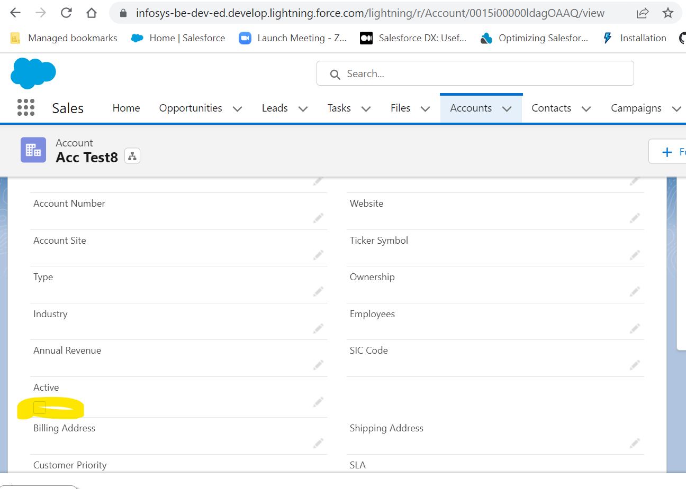

And Two team members record will be created and that relate to same account

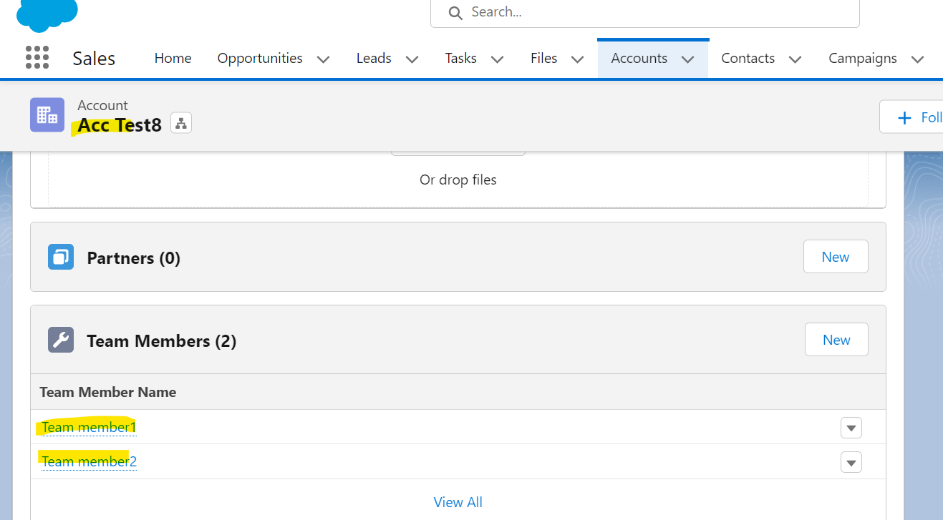

Now I am trying to update account with active value true it will throw error because Team members don’t have Member type.

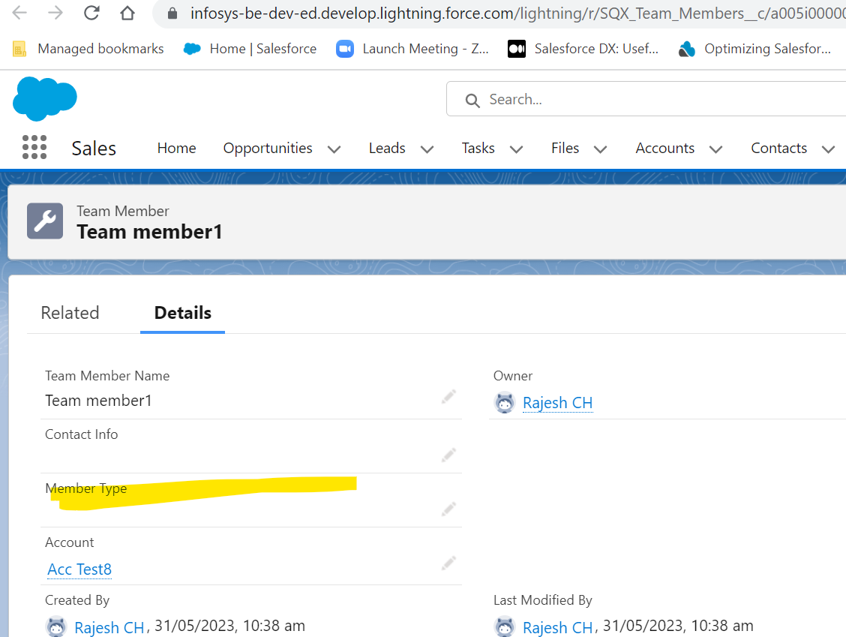

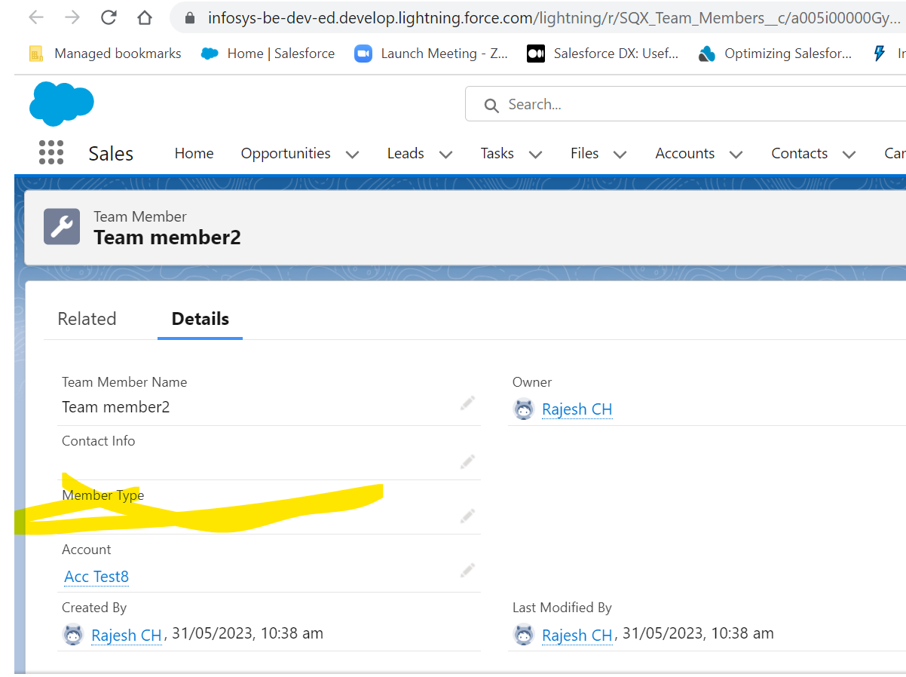

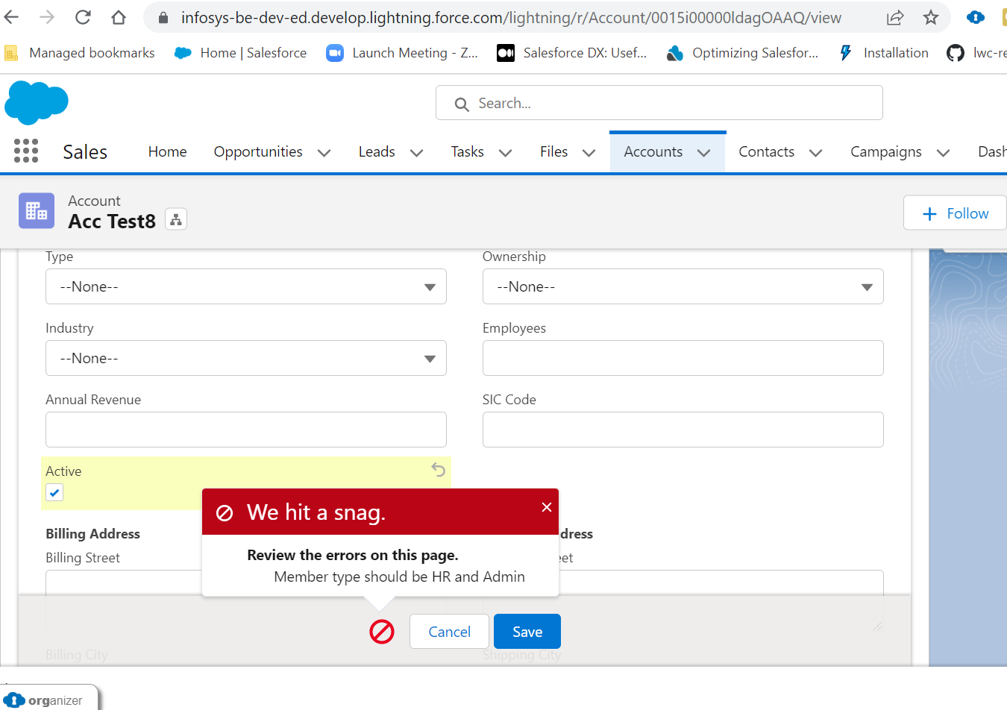

If team members have HR and Admin members type respectively then only we can update Account.

And aslo user should have Account Admin permission set. Currently I am not assigned permission set we will receive error below.

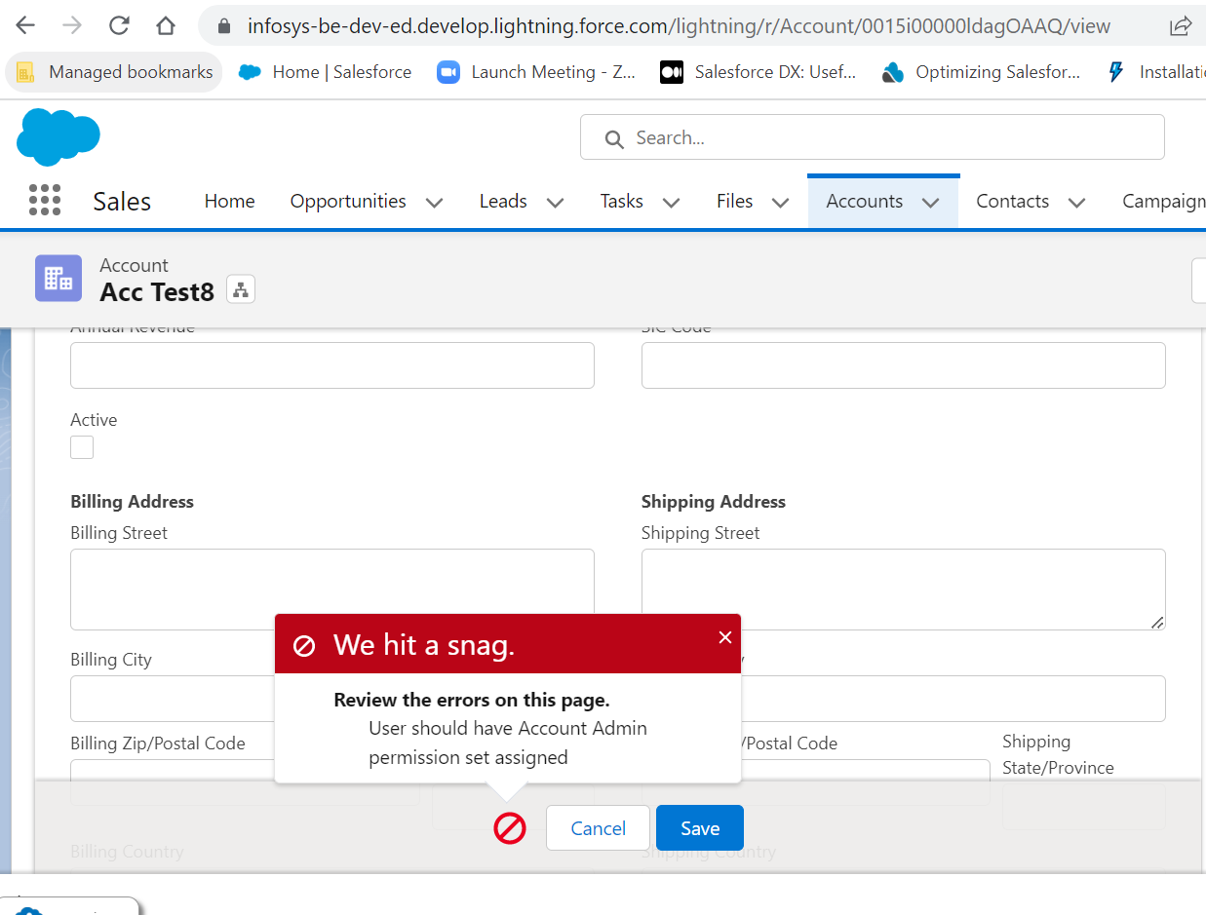

Now I am assigning permission set to user and team members has HR and Admin member types now I can able to update account.

